**Introduction:** A function is an activity (work) but the graph is its reflection. A function is, so to say, completely observed only through its graph as we see that a man’s image is clearly reflected by a mirror. In mathematics the graph of a function is the geometrical representation (visual form) of its equation. In physics the same thing is called the wave which as for the musician is the representation of a sound that a sound source makes.

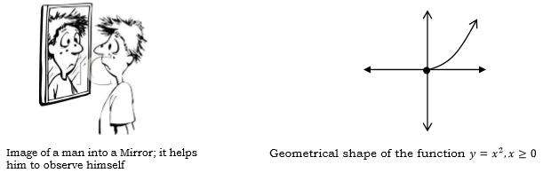

**Graph of Functions**

If $f:A→B$ denotes a function, then the graph of the function $f(x)$ is the set of all ordered pairs $(x,f\left(x\right))$ for all values of *x* in the domain A.

$∴$ Graph of $f\left(x\right)=\{\left(x,y\right):xϵA,y=f\left(x\right)ϵB\}$

Therefore, Graph is the geometrical/Pictorial representation of a function or visualization of a function.

**Graph of some elementary functions:**

* ***Graph of $y=mx$ +c***

Y

X

**m< 0**

O

X

Y

**m> 0**

O

* ***Graph of $y=mx$***

Y

X

O

* ***Graph of*** *⯂****Graph of $y=- x$***

O

Y

X

Y

X

O

* ***Graph of*** *⯂****Graph of $y=x^{2}$***

Y

X

O

Y

X

O

* ***Graph of*** *⯂****Graph of $x=y^{2}$***

Y

X

O

Y

O

X

***Note:*** *when power of the variable increases then graph will be wider.*

* ***Graph of*** *⯂****Graph of $y=\sqrt{x}$***

O

X

O

X

Y

Y

* ***Graph of*** *⯂****Graph of $y=\sqrt{- x}$***

O

X

Y

O

X

Y

* ***Graph of*** *⯂****Graph of $y=\frac{1}{x}$***

O

X

Y

O

X

Y

* ***Graph of*** *⯂****Graph of $y=x^{3}$***

O

X

Y

O

X

Y

* ***Graph of*** *⯂****Graph of $y=e^{x}$***

O

X

Y

(0,1)

O

X

Y

O

X

Y

* ***Graph of*** ⯂***Graph of $y=ln\left|x\right|$***

O

X

Y

(1,0)

(0,1)

* ***Graph of***  *⯂* ***Graph of $y=a^{- x}$***

O

X

Y

(0,1)

O

X

Y

(0,1)

* ***Graph of***  *⯂****Graph of $y=\sqrt{a^{2}-x^{2}}$***

O

X

Y

-a a

O

X

Y

(1,0)

* ***Graph of*** *⯂****Graph of $x^{2}+y^{2}=a^{2}$***

O

X

Y

-a a

O

X

Y

- aa

* ***Graph of*** *⯂****Graph of $\frac{x^{2}}{a^{2}}-\frac{y^{2}}{b^{2}}=1$***

O

X

Y

-a a

-bb

O

X

Y

* ***Graph of $y=sinx$***

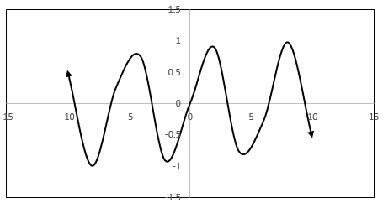

* ***Graph of $y=cosx$***

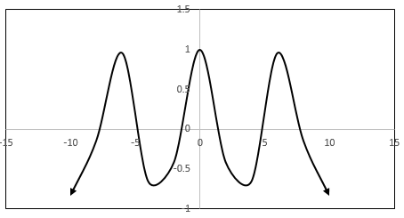

**Gradient:** The gradient is another word for slope. The slope of the [tangent](https://www.collinsdictionary.com/dictionary/english/tangent) at any point on a curve with [respect](https://www.collinsdictionary.com/dictionary/english/respect) to the horizontal [axis](https://www.collinsdictionary.com/dictionary/english/axis) is called gradient of the curve.

**Gradient of a straight line:** Thegradient of a straight line is the rate at which the line rises (or falls) vertically for every unit across to the right. That is:

** **

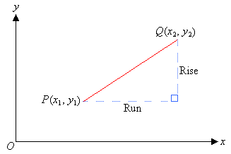

**NOTE:** The gradient of a straight line is denoted by *m* where:

**.**

**Problem-01:** Find the gradient of the straight line joining the points  and ****.

**Solution:** Let  and **.**

The gradient of the straight line joining these points is



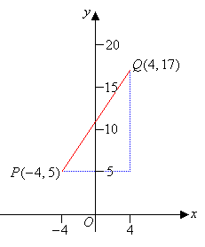

So, the gradient of the line *PQ* is 1.5.

**NOTE:** If the gradient of a line is positive, then the line slopes upward as the value of *x* increases*.*

**Problem-02:** Find the gradient of the straight line joining the points *A*(6, 0) and *B*(0, 3).

**Solution:** Let  and **.**

The gradient of the straight line joining these points is



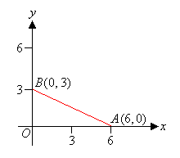

So, the gradient of the line *AB* is - 0.5.

**NOTE:** If the gradient of a line is **negative**, then the line **slopes downward** as the value of *x* increases.

**Gradient of a curve:** The gradient of a curve at any point is given by the gradient of the tangent at that point.

**Problem-03:** Find the gradient of the curve y = x² at the point (3, 9).

**Solution:** We draw a tangent for the given curve at (3, 9).

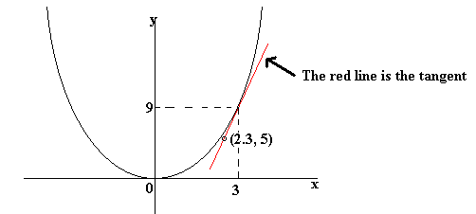

Let  and **.**

The gradient of the tangent is



**NOTE:** This method only gives an approximate answer. The better your graph is, the closer your answer will be to the correct answer. If your graph is perfect, you should get an answer of 6 for the above question.

**NOTE:** 1. Two straight lines will be parallel if the gradients of them are equal.

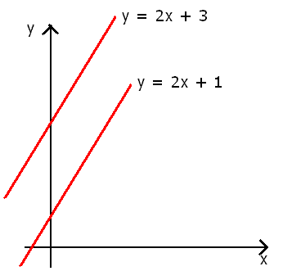

2. Two straight lines will be perpendicular if the product of the gradients of them is equal to -1.

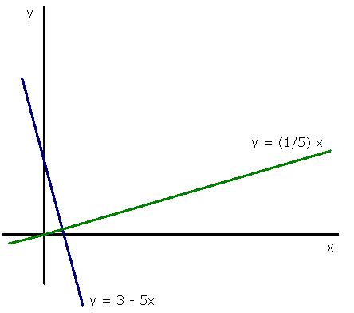

**Exponential function:** A function of the form  is called an exponential function with base *b*.

**Examples:**, ,  , etc.

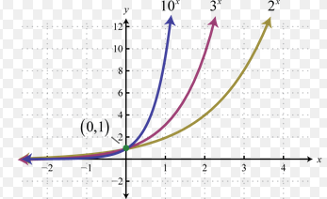

**NOTE: 1.** If the base, b, is greater than 1, then the function increases exponentially at a growth rate of b. This is known as exponential growth.

**2.** If the base, b, is less than 1 (but greater than 0) the function decreases exponentially at a rate of b. This is known as exponential decay.

**3**. If the base, b, is equal to 1, then the function trivially becomes y=a.

**4.** The points (0,1) and (1,b) are always on the graph of the function .

**5.** The function takes on only positive values and has the x-axis as a horizontal asymptote.

**Reason of  :** If b is negative, then raising b to an even power results in a positive value for y while raising b to an odd power results in a negative value for y, making it impossible to join the points obtained an any meaningful way and certainly not in a way that generates a curve.

**Logarithmic function:** A function of the form  is called a logarithmic function with base *b*.

**Examples:**, , etc.

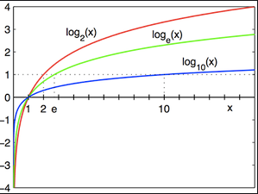

**NOTE: 1.** The point (1,0) is on the graph of all logarithmic functions of the form , where b is a positive real number except 1.

**Arithmetic Progression:** An arithmetic progression (AP) is a [sequence](https://en.wikipedia.org/wiki/Sequence) of [numbers](https://en.wikipedia.org/wiki/Number) such that the difference between the consecutive terms is constant. Difference here means the second minus the first. For instance, the sequence 5, 7, 9, 11, 13, 15, . . . is an arithmetic progression with common difference of 2.

The general form of arithmetic progression is,



The common difference is,



The nth term of the sequence is,



The sum of n terms of this sequence is,

 or, .

**Geometric Progression:** An arithmetic progression (GP) is a [sequence](https://en.wikipedia.org/wiki/Sequence) of [numbers](https://en.wikipedia.org/wiki/Number) where each term after the first is found by multiplying the previous one by a fixed, non-zero number called the common ratio. For example, the sequence 2, 6, 18, 54, ... is a geometric progression with common ratio 3. Similarly 10, 5, 2.5, 1.25, ... is a geometric sequence with common ratio 1/2.

The general form of geometric progression is,



The common ratio is,



The nth term of the sequence is,



The sum of n terms of this sequence is,

 .

**Permutation:** A permutation is a mathematical technique that determines the number of possible arrangements in a set of objects where the order of the selection does matter. For example, suppose we have a set of three letters: A, B, and C. We might ask how many ways we can arrange 2 letters from that set. Each possible arrangement would be an example of a permutation. The complete list of possible permutations would be: AB, AC, BA, BC, CA, and CB.

The number of permutations of n distinct objects taken r at a time is determined by the following formula:

 .

The number of permutations of n distinct objects taken all at a time is determined by the following formula:

 .

**Problem-01:** Find the number of words, with or without meaning, that can be formed with the letters of the word ‘TABLE’.

**Solution:** ‘TABLE’ contains 5 letters.

Therefore, the number of words that can be formed with these 5 letters



**Problem-02:** Find the number of words, with or without meaning, that can be formed with the letters of the word ‘INDIA’.

**Solution:** The word ‘INDIA’ contains 5 letters and ‘I’ comes twice.

When a letter occurs more than once in a word, we divide the factorial of the number of all letters in the word by the number of occurrences of each letter.

Therefore, the number of words formed by ‘INDIA’ .

**Problem-03:** Find the number of words, with or without meaning, that can be formed with the letters of the word ‘SWIMMING?

**Solution:** The word ‘SWIMMING contains 8 letters. Of which, I occurs twice and M occurs twice.

Therefore, the number of words formed by this word .

**Problem-04:** How many different words can be formed with the letters of the word ‘SUPER’ such that the vowels always come together?

**Solution:** The word ‘SUPER’ contains 5 letters.

In order to find the number of permutations that can be formed where the two vowels U and E come together.

In these cases, we group the letters that should come together and consider that group as one letter.

So, the letters are S,P,R, (UE). Now the number of words are 4.

Therefore, the number of ways in which 4 letters can be arranged is 

In U and E, the number of ways in which U and E can be arranged is 

Hence, the total number of ways in which the letters of the ‘SUPER’ can be arranged such that vowels are always together are  ways.

**Problem-05:** Find the number of different words that can be formed with the letters of the word ‘BUTTER’ so that the vowels are always together.

**Solution:** The word ‘BUTTER’ contains 6 letters.

The letters U and E should always come together. So the letters are B, T, T, R, (UE).

Number of ways in which the letters above can be arranged (since the letter ‘T’ is repeated twice).

Number of ways in which U and E can be arranged = 2! = 2 ways

Therefore, total number of permutations possible ways.

**Combination:** A combination is a mathematical technique that determines the number of possible arrangements in a set of objects where the order of the selection does not matter. For example, suppose we have a set of three letters: A, B, and C. We might ask how many ways we can arrange 2 letters (with no repetition) from that set. Each possible arrangement would be an example of a combination. The complete list of possible combinations would be: AB, AC and BC.

Mathematically, the formula for determining the number of possible arrangements by selecting only a few objects from a set with no repetition is expressed in the following way:

 .

The formula for determining the number of possible arrangements by selecting only a few objects from a set with repetition is expressed in the following way:



**Note:** If the order doesn't matter then we have a combination, if the order do matter then we have a permutation. One could say that a permutation is an ordered combination.

**Problem-1:** In how many ways can a coach choose three swimmers from among five swimmers?

**Solution:** There are 5 swimmers to be taken 3 at a time.

Using the formula:



The coach can choose the swimmers in 10 ways.

**Problem-02:** Six friends want to play enough games of chess to be sure everyone plays everyone else. How many games will they have to play?

**Solution:** There are 6 players to be taken 2 at a time.

Using the formula:



They will need to play 15 games.

**Problem-03:** Out of 7 consonants and 4 vowels, how many words of 3 consonants and 2 vowels can be formed?

**Solution:** Number of ways of selecting 3 consonants from 7 is .

Number of ways of selecting 2 vowels from 4 is .

Number of ways of selecting 3 consonants from 7 and 2 vowels from 4 is .

It means we can have 210 groups where each group contains total 5 letters *(3 consonants and 2 vowels)*.

Number of ways of arranging 5 letters among themselves is .

Hence, required number of ways is .

**Problem-04:** From a group of 7 men and 6 women, five persons are to be selected to form a committee so that at least 3 men are there in the committee. In how many ways can it be done?

**Solution:** Hence we have the following 3 options.

We can select 5 men ... (option 1)

Number of ways to do this is .

We can select 4 men and 1 woman ... (option 2)

Number of ways to do this is .

We can select 3 men and 2 women ... (option 3)

Number of ways to do this is 

Total number of ways is .

**Binomial Theorem:** The binomial theorem (or binomial expansion) describes the algebraic expansion of [powers](https://en.wikipedia.org/wiki/Exponentiation) of a [binomial](https://en.wikipedia.org/wiki/Binomial_(polynomial)). According to the theorem, it is possible to expand the polynomialinto a [sum](https://en.wikipedia.org/wiki/Summation) involving terms of the form , where the exponents *b* and *c* are [nonnegative integers](https://en.wikipedia.org/wiki/Nonnegative_integer) with , and the binomial [coefficient](https://en.wikipedia.org/wiki/Coefficient) *a* of each term is a specific [positive integer](https://en.wikipedia.org/wiki/Positive_integer) depending on *n* and *b*.



For 







